23. SQL – Table School
AIM:
To create a table school and execute the below given queries:
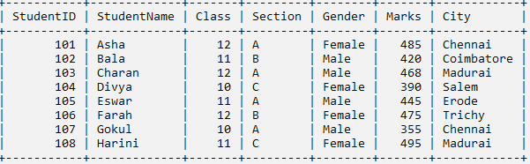

QUERIES:
- To describe the structure of the table.
DESC school;

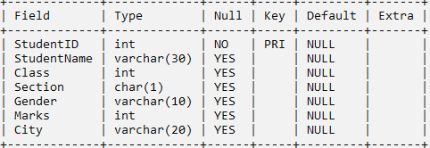

- Update the marks of student Asha to 490.
UPDATE SCHOOL SET Marks = 490 WHERE StudentName='Asha';

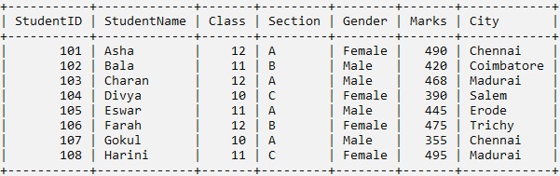

- Change the datatype of City from VARCHAR(20) to VARCHAR(40).
ALTER TABLE SCHOOL MODIFY City VARCHAR(40);

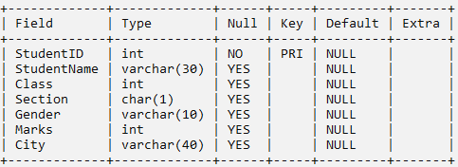

- Add a new column Grade.
ALTER TABLE SCHOOL ADD Grade CHAR(1);

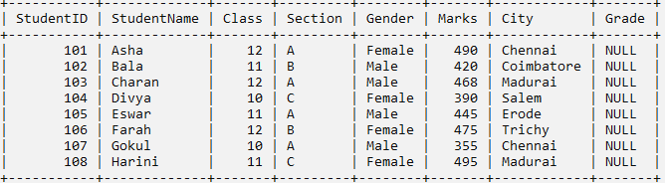

- To change the column name studentname to sname
ALTER TABLE SCHOOL RENAME COLUMN studentname to sname;

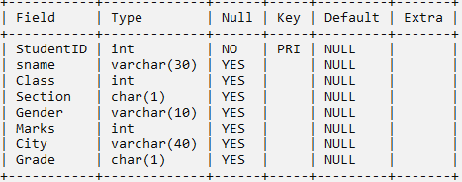

- To remove the column grade.
ALTER TABLE school DROP COLUMN grade;

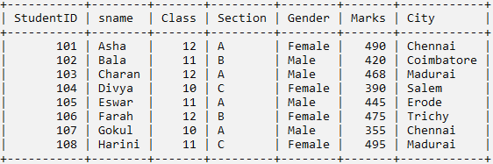

- Insert a new row.
INSERT INTO school VALUES(109,'Raju',12,'A','Male',452,'Chennai');

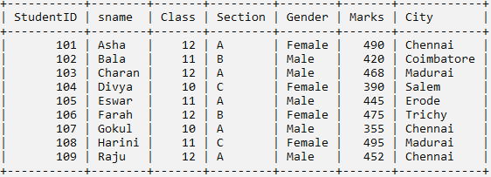

- To increase 5 marks for all the male students.
UPDATE school SET marks =marks+5 WHERE gender ='Male';

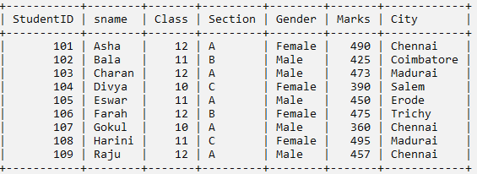

- To remove the student named ‘Eswar’.
DELETE FROM school WHERE sname='Eswar';

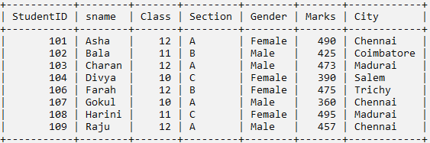

- To remove the table school.
DROP TABLE school;

RESULT:
The queries are executed successfully and the output is obtained.

24. SQL – Table Employee
AIM:
To create the table employee and execute the below given queries.
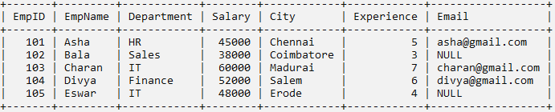

QUERIES:
- Display all employee details in ascending order of salary.
SELECT * FROM EMPLOYEE ORDER BY Salary;
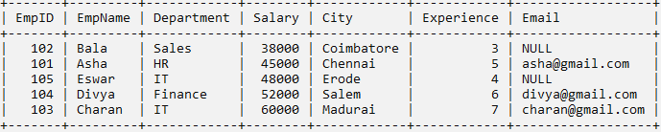
- Display employee names and salaries in descending order of salary.
SELECT EmpName, Salary FROM EMPLOYEE ORDER BY Salary DESC;
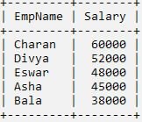
- Display employees whose salary is between 40000 and 55000.
SELECT * FROM EMPLOYEE WHERE Salary BETWEEN 40000 AND 55000;
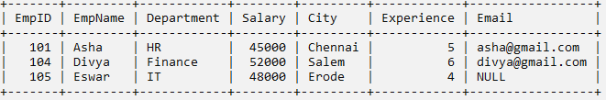
- Display employees whose names start with 'A'.
SELECT * FROM EMPLOYEE WHERE EmpName LIKE 'A%';
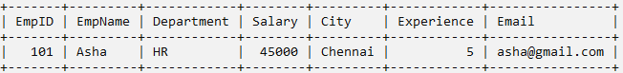
- Display employees whose city contains 'du'.
SELECT * FROM EMPLOYEE WHERE City LIKE '%du%';
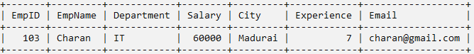
- Display employees working in IT or HR departments.
SELECT * FROM EMPLOYEE WHERE Department IN ('IT','HR');
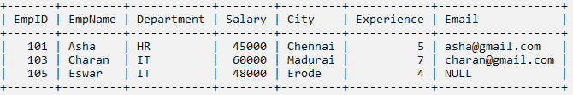
- Display employees whose email address is NULL.
SELECT * FROM EMPLOYEE WHERE Email IS NULL;
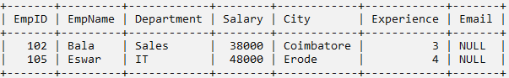
- Display employees whose department is not 'IT'.
SELECT * FROM EMPLOYEE WHERE Department <> 'IT';
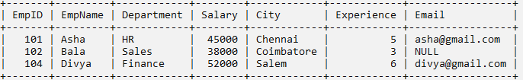
- Display employees earning less than 45,000.
SELECT * FROM EMPLOYEE WHERE Salary < 45000;
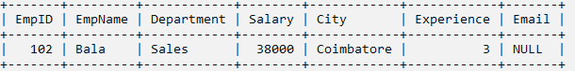
- Display employees whose city is 'Chennai'.
SELECT * FROM EMPLOYEE WHERE City = 'Chennai';
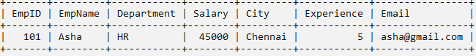

RESULT:
The queries are executed successfully and the output is obtained.

25. SQL – Table Cars – Aggregate Functions
AIM:
To create the table name car and execute the below given queries.
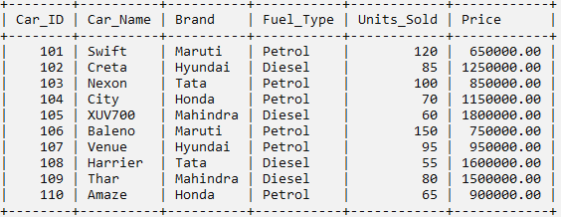

QUERIES:
- To count the total number of cars.
SELECT COUNT(*) AS Total_Cars FROM cars;

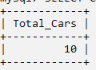

- To find total units sold.
SELECT SUM(Units_Sold) AS Total_Units_Sold FROM cars;

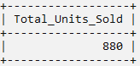

- To find the average units sold for fuel_type petrol;
SELECT AVG(Units_Sold) FROM cars where Fuel_Type='Petrol';

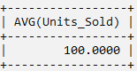

- To find minimum units sold.
SELECT MAX(Units_Sold) FROM cars;

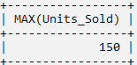

- To find the lowest car price.
SELECT MIN(Price) AS Lowest_Price FROM cars;

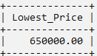

- To count cars sold by each brand.
SELECT Brand, COUNT(*) FROM cars GROUP BY Brand;
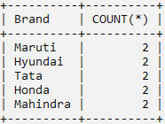
- Find average units sold by each brand.
SELECT Brand, AVG(Units_Sold) FROM cars GROUP BY Brand;

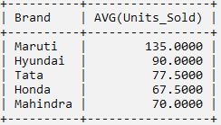

- Find brands having total sales above 200 units.
SELECT Brand, SUM(Units_Sold) FROM cars GROUP BY Brand HAVING SUM(Units_Sold) > 200;

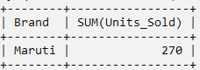

- Display brands whose total units sold is more than 75.
SELECT Brand, SUM(units_sold) FROM cars GROUP BY Brand HAVING SUM(units_sold) > 8;
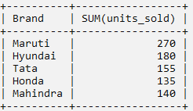
- Display the total quantity of cars sold by each brand for cars priced above 8,00,000.
SELECT Brand, SUM(units_sold) FROM cars WHERE Price > 800000 GROUP BY Brand;

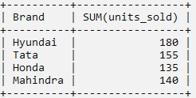

RESULT:
The Queries are executed successfully and the output is obtained.

26. SQL – Table Flight & Fares
AIM:
To create the table flight and fare and execute the below given queries.
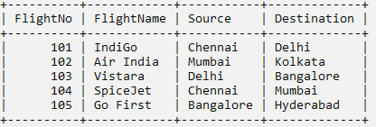
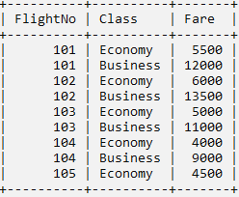
QUERIES:
1. Display flight name and fare.
SELECT Flight.FlightName, Fares.Fare FROM Flight, Fares WHERE
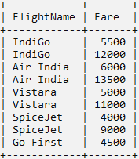
Flight.FlightNo = Fares.FlightNo;

2. Display all flight details with class and fare.
SELECT Flight.FlightNo, Flight.FlightName,Flight.Source, Flight.Destination,Fares.Class, Fares.Fare
FROM Flight, Fares WHERE Flight.FlightNo = Fares.FlightNo;
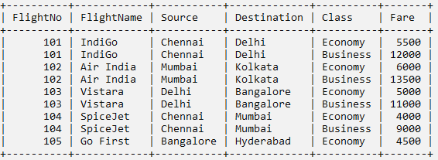
3. Display flights having Economy class.
SELECT Flight.FlightName, Flight.Source,Flight.Destination, Fares.Fare FROM Flight, Fares WHERE Flight.FlightNo = Fares.FlightNo AND Fares.Class = 'Economy';
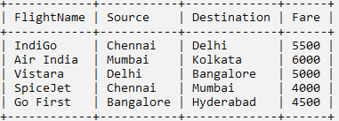
4. Display flights with fare above 5000.
SELECT Flight.FlightName, Fares.Class, Fares.Fare FROM Flight, Fares WHERE Flight.FlightNo = Fares.FlightNo
AND Fares.Fare > 5000;
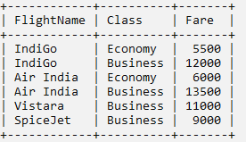
5. Display flight name, source, destination and business fare.
SELECT Flight.FlightName, Flight.Source,Flight.Destination, Fares.Fare FROM Flight, Fares WHERE Flight.FlightNo = Fares.FlightNo AND Fares.Class = 'Business';
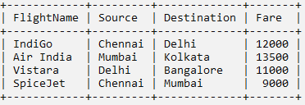

RESULT:
The queries are executed successfully and the output is obtained.

